DEPOE BAY RURAL FIRE PROTECTION DISTRICT BOARD OF DIRECTORS SPECIAL MEETING
Tuesday, April 7, 2024
3 PM
Station 22 • Gleneden Beach
6445 Gleneden Beach Loop – Gleneden Beach, OR

***AGENDA***

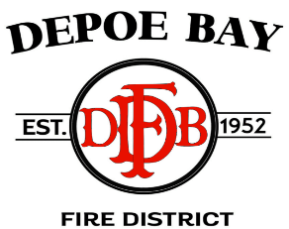

CALL TO ORDER – Pledge of Allegiance

ROLL CALL

- NEW BUSINESS

    - Fire Chief’s Swearing In and Oath of Office

- OLD BUSINESS

    - Fire Chief’s Employment Agreement

PUBLIC COMMENTS AND/OR QUESTIONS

AGENDA SUGGESTIONS – OPEN

ADJOURN
Next scheduled meeting: Budget Meeting and Regular Board Meeting - Tuesday, May 14, 2024, at Gleneden Beach Fire Station 22: 6445 Gleneden Beach Loop, Gleneden Beach, Oregon 97388
Depoe Bay Fire District - Board of Directors Meeting
Please join my meeting from your computer, tablet or smartphone.
https://global.gotomeeting.com/join/833057797
You can also dial in using your phone.
United States: +1 (872) 240-3311
Access Code: 833-057-797
New to GoToMeeting? Get the app now and be ready when your first meeting starts: https://global.gotomeeting.com/install/833057797

